AI-QIS Quality Innovation Suite
Process Improvement Project Report
Prepared by: SME Assistant
Department: Sample Analysis
Period: 2025
Date: 2025-12-20

─────────────────────────
AI-QIS Professional
Quality Intelligence Suite

Executive Report

1. Executive Summary
This report documents the quality improvement initiative "Improve Customer Service Response Time". The project addresses: Current average customer service response time is 48 hours, well above industry benchmark of 4 hours. This results in CSAT score of 65% (target 85%), customer churn rate of 12% annually, and negative social media reviews averaging 15 per month. The improvement goal: Reduce average response time from 48 hours to 4 hours within 6 months, improve CSAT from 65% to 85%, reduce customer churn from 12% to 5%, eliminate negative social media reviews related to response time. Process analysis shows: Problem: Current average customer service response time is 48 hours, well above industry benchmark of 4 hours. This results in CSAT score of 65% (target 85%), customer churn rate of 12% annually, and negative social media reviews averaging 15 per month. Performance baseline: 48 hours, Target: 4 hours. Current performance: 24 hours - improvement in progress. The improvement team includes 3 member(s). Success will be measured by meeting 4 project acceptance criteria (Response time ≤ 4 hours, CSAT ≥ 85%, etc.). This analysis encompasses 5 quality tool(s).

2. Key Insights Across All Tools

2.1 Performance Gaps
- Response time 48 hours exceeds benchmark (4 hours)
- CSAT score 65% below target (85%)
- Customer churn rate 12% annually
- Negative social media reviews: 15 per month

2.2 Trend/Variation
- Avg Response Time: Baseline 48 hours → Current 24 hours → Target 4 hours
- CSAT Score: Baseline 65 % → Current 72 % → Target 85 %
- Customer Churn Rate: Baseline 12 % → Current 9 % → Target 5 %
- First Contact Resolution: Baseline 45 % → Current 58 % → Target 75 %

2.3 Resource/Capability
- Cross-functional team of 3 members assigned
- Project lead: Rachel Lim (CX Manager)
- Timeline: 2025-12-15 to 2026-06-15
- [S] Experienced customer service team (avg 5 years)

2.4 Opportunity/Risk
- [O] AI chatbot can handle 60% of routine queries
- [O] Competitor response time is 12 hours (we can beat)
- [T] New competitor launching 24/7 AI support
- [T] Rising customer expectations post-pandemic

3. Performance Snapshot

3.1 Performance Summary
Metric Characteristic: Smaller is Better
Reduce the metric toward target. Improvement is achieved when values decrease.
Table E.1: Performance Summary
Metric | Value | Status
Baseline | 48 hours | Starting point
Current | 24 hours | In progress
Target | 4 hours | In Progress

Performance Change Summary
↓ 50.0% improvement from baseline (48 hours → 24 hours)
Gap to target: 20.0 hours remaining
Performance Journey:
48 hours → 24 hours → 4 hours
(Baseline) (Current) (Target)

3.2 Success Criteria Assessment
0/4 criteria met (0%) | 2 in progress
- Response time ≤ 4 hours: 95% of tickets within 4 hrs [In Progress]
- CSAT ≥ 85%: Monthly average ≥ 85% [In Progress]
- Churn rate ≤ 5%: Monthly churn ≤ 5% [Not Started]
- Chatbot adoption: 60% of inquiries handled by chatbot [Not Started]

4. Synthesized Root Cause Themes
Analysis indicates several contributing factors requiring attention. Addressing these systematically will reduce variation and improve results.
- 24 causes across 6 categories
- Man (People): 4
- Machine: 4
- Method: 4

5. Priority Recommendations
- Address stakeholder concerns from 1 skeptic/resistor(s)
- Address top contributor "Long Wait Times" (33.5% impact)
- Investigate Man (People) category (4 causes identified)
- Process stable - maintain control chart monitoring

6. 30-Day Action Roadmap
Table E.2: 30-Day Action Roadmap
Timeframe | Action | Expected Outcome
Week 1 (PLAN) | Schedule stakeholder engagement sessions | Baseline established
 | Root cause analysis on "Long Wait Times"
Week 2 (DO) | Validate Man (People) root causes with data | Implementation started
Week 3 (CHECK) | Review results against targets | Results verified
 | Identify gaps
Week 4 (ACT) | Continue control chart monitoring | Standardization complete

7. Risks, Constraints & Data Gaps

7.1 Key Risks
- [T] New competitor launching 24/7 AI support
- [T] Rising customer expectations post-pandemic
- [T] Staff turnover in customer service industry
- [T] Economic downturn may reduce CX budget

7.2 Constraints
- Cannot change existing CRM vendor (contract until 2026)
- Must complete before Q2 end
- Union approval required for role changes

7.3 Data Gaps
- Historical response time data only available for last 6 months
- No baseline data for chatbot-specific metrics
- Customer segmentation data incomplete

8. Next Steps
- Implement priority recommendations identified in this analysis
- Address data gaps to enable more comprehensive analysis
- Refine process based on insights from process analysis tools
- Execute 30-day roadmap and track milestones

Table of Contents
Executive Report ii
1. Executive Summary ii
2. Key Insights Across All Tools ii
2.1 Performance Gaps ii
2.2 Trend/Variation ii
2.3 Resource/Capability iii
2.4 Opportunity/Risk iii
3. Performance Snapshot iii
3.1 Performance Summary iii
3.2 Success Criteria Assessment iv
4. Synthesized Root Cause Themes iv
5. Priority Recommendations iv
6. 30-Day Action Roadmap iv
7. Risks, Constraints & Data Gaps v
7.1 Key Risks v
7.2 Constraints v
7.3 Data Gaps v
8. Next Steps v
Table of Contents vi
Detailed Tool Outputs ix
1. Tool 1: Project Charter 1
1.1 Project Charter Overview 1
1.1.1 Charter Summary Visual 1
1.1.2 SMART Objectives 1
1.2 Project Information 2
1.3 Project Team 2
1.3.1 Project Leader 2
1.3.2 Team Members 2
1.4 Problem and Goal Statements 3
1.4.1 Problem Statement 3
1.4.2 Goal Statement 3
1.5 Project Scope 3
1.5.1 In Scope 3
1.5.2 Out of Scope 3
1.6 Project Timeline and Milestones 3
1.6.1 Project Duration 3
1.6.2 Key Milestones 4
1.7 Project Charter Findings 4
2. Tool 2: Histogram Distribution Analysis 5
2.1 Histogram Distribution Analysis Overview 5
2.2 Histogram Distribution Analysis Application 5
2.3 Statistical Summary 5
2.4 Distribution Breakdown 6
2.5 Histogram Visualization 6
2.6 Histogram Distribution Analysis Findings 6
3. Tool 3: Pareto Analysis 8
3.1 Pareto Analysis Overview 8
3.2 Pareto Analysis Application 8
3.3 Comprehensive Data Table 8
3.4 Target Cumulative % Threshold 9
3.5 Pareto Chart Visualization 9
3.6 Pareto Analysis Findings 9
4. Tool 4: Fishbone/Ishikawa Diagram 11
4.1 Fishbone/Ishikawa Overview 11
4.2 Problem Statement (HEAD) 11
4.3 Identified Causes by Category 11
4.4 Fishbone Diagram 12
4.5 Fishbone Findings 13
5. Tool 5: Control Chart 14
5.1 Control Chart Overview 14
5.2 Control Chart Application 14
5.3 Measurement Data 14
5.4 Control Chart Visualization 14
5.5 Process Analysis 15
5.5.1 Statistical Summary 15
5.5.2 Control Limits 15
5.5.3 Process Status 16
5.6 Control Chart Findings 16

Detailed Tool Outputs
The following sections present the detailed outputs of each tool used in the project. All tools appear in their original format exactly as generated in AI-QIS.
Table E.1: Project's Tool Overview
Tool # | Tool Name | Description
Tool 1 | Project Charter | Defines project scope, objectives, team, and success criteria
Tool 2 | Histogram Distribution Analysis | Distribution analysis of process data
Tool 3 | Pareto Analysis | Identifies vital few causes contributing to majority of problems
Tool 4 | Fishbone/Ishikawa Diagram | Root cause analysis using Ishikawa diagram (6M categories)
Tool 5 | Control Chart | Control chart for process stability monitoring

Tool 1: Project Charter

1.1 Project Charter Overview
A Project Charter is the foundational document that formally authorizes a quality improvement project. It defines the problem, goal, scope, timeline, team, and resources. The charter aligns stakeholders on objectives and provides clear direction for the project team throughout execution.

1.1.1 Charter Summary Visual
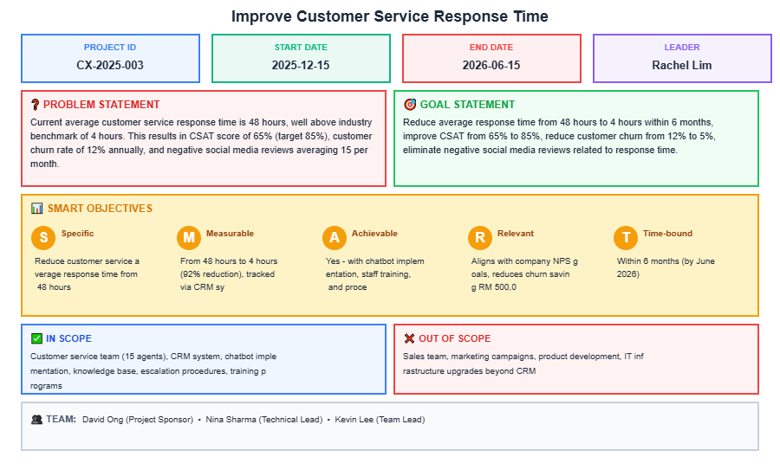
Figure 1.1: Project Charter Summary

1.1.2 SMART Objectives
The project objectives have been defined using SMART criteria to ensure clarity and measurability:
Table 1.1: SMART Objectives
SMART | Criteria | Project Objective
S - Specific | What exactly will be accomplished? | Reduce customer service average response time from 48 hours to 4 hours
M - Measurable | How will success be measured? | From 48 hours to 4 hours (92% reduction), tracked via CRM system metrics
A - Achievable | Is this realistic with resources? | Yes - with chatbot implementation, staff training, and process optimization
R - Relevant | Why does this matter? | Aligns with company NPS goals, reduces churn saving RM 500,000/year
T - Time-bound | When will this be completed? | Within 6 months (by June 2026)

1.2 Project Information
Project Name: Improve Customer Service Response Time Project Code: CX-2025-003
Start Date: 2025-12-15 End Date: 2026-06-15

1.3 Project Team

1.3.1 Project Leader
Table 1.2: Project Leader Information
Name | Department | Role/Position | Email
Rachel Lim | Customer Experience | CX Manager | rachel.lim@company.com

1.3.2 Team Members
Table 1.3: Team Members Information
Name | Department | Role | Email
David Ong | Operations | Project Sponsor | david.ong@company.com
Nina Sharma | IT | Technical Lead | nina.sharma@company.com
Kevin Lee | Customer Service | Team Lead | kevin.lee@company.com

1.4 Problem and Goal Statements

1.4.1 Problem Statement
Current average customer service response time is 48 hours, well above industry benchmark of 4 hours. This results in CSAT score of 65% (target 85%), customer churn rate of 12% annually, and negative social media reviews averaging 15 per month.

1.4.2 Goal Statement
Reduce average response time from 48 hours to 4 hours within 6 months, improve CSAT from 65% to 85%, reduce customer churn from 12% to 5%, eliminate negative social media reviews related to response time.

1.5 Project Scope

1.5.1 In Scope
Customer service team (15 agents), CRM system, chatbot implementation, knowledge base, escalation procedures, training programs

1.5.2 Out of Scope
Sales team, marketing campaigns, product development, IT infrastructure upgrades beyond CRM

1.6 Project Timeline and Milestones

1.6.1 Project Duration
6 months (182 days) from 2025-12-15 to 2026-06-15

1.6.2 Key Milestones
Table 1.4: Project Milestones
Milestone | Target Date | Status
Project Kick-off & Team Formation | 2025-12-15 | Completed
Current State Analysis Complete | 2026-01-14 | Completed
Chatbot Vendor Selection | 2026-01-29 | In Progress
Chatbot Development & Testing | 2026-03-15 | Not Started
Agent Training Complete | 2026-04-14 | Not Started
Go-Live & Monitoring | 2026-05-14 | Not Started
Project Closure & Handover | 2026-06-15 | Not Started
Progress: 2/7 completed | 1 in progress

1.7 Project Charter Findings
Complete Project Charter with all elements documented. The charter provides comprehensive project authorization and is ready for executive approval.
Table 1.5: Charter Completion Status
# | Element | Status | # | Element | Status
1 | Project Information | ✓ Complete | 10 | Performance Metrics | ✓ Complete
2 | Project Milestones | ✓ Complete | 11 | Success Criteria | ✓ Complete
3 | Project Leader | ✓ Complete | 12 | Business Case | ✓ Complete
4 | Project Team | ✓ Complete | 13 | Project Scope | ✓ Complete
5 | Stakeholder Analysis | ✓ Complete | 14 | Resources Required | ✓ Complete
6 | Problem Statement | ✓ Complete | 15 | Deliverables | ✓ Complete
7 | Performance Gaps | ✓ Complete | 16 | Risks & Constraints | ✓ Complete
8 | Goal Statement | ✓ Complete | 17 | SWOT Analysis | ✓ Complete
9 | SMART Objectives | ✓ Complete
 |  | Overall: | 17/17 (100%)

Tool 2: Histogram Distribution Analysis

2.1 Histogram Distribution Analysis Overview
A Histogram displays the frequency distribution of continuous data by grouping values into ranges (bins). This visualization reveals the shape, spread, and central tendency of data, helping identify process capability, stability, and potential quality issues. Common distribution patterns include normal (bell curve), skewed (asymmetric), or bimodal (two peaks), each indicating different process behaviors. Histograms are essential for understanding process variation and capability.

2.2 Histogram Distribution Analysis Application
Total Observations: 45 data points
Distribution: Symmetric (Normal)
Variation Level: Low (CV = 0.5%)

2.3 Statistical Summary
Table 2.1: Histogram Statistical Summary
Statistic | Value
Total Observations | 45
Mean (Average) | 50.08
Median | 50.10
Standard Deviation | 0.25
Range | undefined to undefined
Coefficient of Variation | 0.5%

2.4 Distribution Breakdown
Bin # | Range | Frequency | Percentage
1 | 49.2-49.4 | 1 | 2.2%
2 | 49.4-49.5 | 1 | 2.2%
3 | 49.6-49.7 | 2 | 4.4%
4 | 49.7-49.9 | 3 | 6.7%
5 | 49.9-50.1 | 9 | 20.0%
6 | 50.1-50.3 | 18 | 40.0%
7 | 50.3-50.4 | 8 | 17.8%
8 | 50.4-50.6 | 3 | 6.7%
TOTAL |  | 45 | 100.0%

2.5 Histogram Visualization
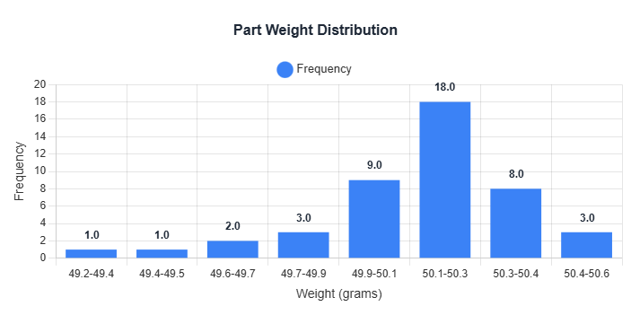
Figure 2.1: Histogram Distribution Chart

2.6 Histogram Distribution Analysis Findings
• Total observations: 45
• Mean: 50.08 | Median: 50.10 | Std Dev: 0.25
• Coefficient of Variation: 0.5%
• Distribution type: Normal
• Assessment: Low variation - process well controlled

Tool 3: Pareto Analysis

3.1 Pareto Analysis Overview
Pareto Analysis applies the 80/20 principle (Pareto Principle) to identify the vital few factors that contribute to the majority of effects. Named after Italian economist Vilfredo Pareto, this tool reveals that approximately 80% of problems stem from 20% of causes. By focusing improvement efforts on these critical few factors, organizations achieve maximum impact with minimal resources. Pareto charts combine bar graphs (showing frequency) with line graphs (showing cumulative percentage) to visually identify the most significant contributors.

3.2 Pareto Analysis Application
This analysis examines 6 categories with a total frequency of 155 occurrences.
Top Contributors: The top 3 categories account for 73.5% of all occurrences.
Target Cumulative % Threshold: 80% (80/20 Rule)

3.3 Comprehensive Data Table
Table 3.1: Pareto Analysis Data
Rank | Category | Frequency | Percentage | Cumulative % | 80/20 Status
1 | Long Wait Times | 52 | 33.5% | 33.5% | Vital Few
2 | Billing Errors | 38 | 24.5% | 58.1% | Vital Few
3 | Poor Staff Attitude | 24 | 15.5% | 73.5% | Vital Few
4 | Incorrect Information | 18 | 11.6% | 85.2% | Useful Many
5 | Website Issues | 15 | 9.7% | 94.8% | Useful Many
6 | Other | 8 | 5.2% | 100.0% | Useful Many

3.4 Target Cumulative % Threshold
Table 3.2: 80/20 Rule Threshold Summary
🎯 Target Cumulative % Threshold
80%
Classic 80/20 Rule Applied

3.5 Pareto Chart Visualization
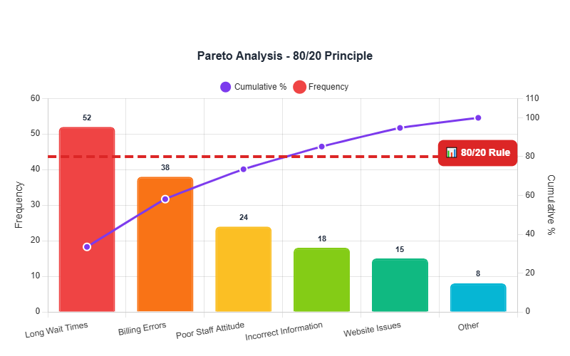
Figure 3.1: Pareto Chart showing frequency distribution and cumulative percentage

3.6 Pareto Analysis Findings
• Total categories analyzed: 6
• Top contributor: "Long Wait Times" (52 occurrences, 33.5%)
• Top 3 cumulative impact: 73.5% of total
• Assessment: Moderate effect - prioritize top contributors

Tool 4: Fishbone/Ishikawa Diagram

4.1 Fishbone/Ishikawa Overview
The Fishbone (Ishikawa) diagram is a root cause analysis tool that organizes potential causes of a problem into categories. The 6M method examines: Man (People), Machine (Equipment), Method (Process), Material (Raw materials), Measurement (Inspection), and Mother Nature (Environment).

4.2 Problem Statement (HEAD)
Low Customer Satisfaction Score

4.3 Identified Causes by Category
Man (People)
- Insufficient training
- High staff turnover
- Lack of product knowledge
- Poor communication skills
Machine (Equipment)
- Slow CRM system
- Frequent system crashes
- Outdated phone system
- Inadequate chat platform
Method (Process)
- No standard scripts
- Inconsistent escalation process
- Long approval chains
- No first-call resolution focus
Material (Inputs)
- Incomplete customer data
- Poorly written knowledge base
- Outdated FAQs
- Missing product documentation
Measurement (Inspection)
- No quality monitoring
- Inconsistent survey methods
- Delayed feedback collection
- No CSAT benchmarking
Mother Nature (Environment)
- Noisy work environment
- Poor seating ergonomics
- High call volume periods
- Remote work tech issues

4.4 Fishbone Diagram
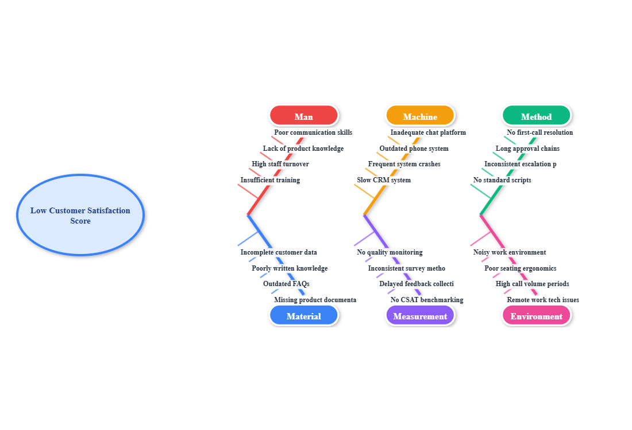
Figure 4.1: Fishbone (Ishikawa) Diagram showing 6M root cause categories

4.5 Fishbone Findings
Good analysis with 24 potential causes identified across multiple categories. This represents comprehensive brainstorming. Next step: Prioritize causes using data, vote for most likely root causes, or use 5 Whys to drill deeper.

Tool 5: Control Chart

5.1 Control Chart Overview
Control Charts monitor process performance over time to distinguish between common cause variation (inherent to process) and special cause variation (assignable to specific factors). Charts display data points with Upper Control Limit (UCL), Center Line (mean), and Lower Control Limit (LCL) at ±3 standard deviations.

5.2 Control Chart Application
Tool Applied: Control Chart (I-MR / X-bar)
Process Name: Beverage Fill Volume Monitoring
Data Points: 20 measurements recorded

5.3 Measurement Data
Sample | Value | Sample | Value | Sample | Value | Sample | Value
Batch 1 | 498.00 | Batch 2 | 503.00 | Batch 3 | 497.00 | Batch 4 | 505.00
Batch 5 | 492.00 | Batch 6 | 501.00 | Batch 7 | 508.00 | Batch 8 | 495.00
Batch 9 | 502.00 | Batch 10 | 499.00 | Batch 11 | 506.00 | Batch 12 | 494.00
Batch 13 | 500.00 | Batch 14 | 507.00 | Batch 15 | 496.00 | Batch 16 | 503.00
Batch 17 | 498.00 | Batch 18 | 504.00 | Batch 19 | 493.00 | Batch 20 | 501.00

5.4 Control Chart Visualization
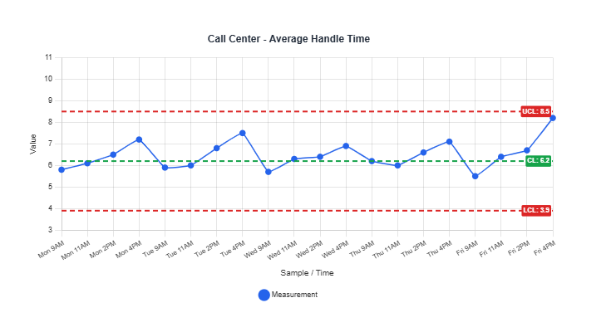
Figure 5.1: Control Chart showing process data with UCL, Center Line, and LCL

5.5 Process Analysis

5.5.1 Statistical Summary
Table 5.1: Control Chart Statistical Summary
Statistic | Value
Sample Size (n) | 20
Mean (X-bar) | 500.100
Standard Deviation (sigma) | 4.592
Range (Min - Max) | 492.00 - 508.00

5.5.2 Control Limits
Table 5.2: Control Limits Summary
Limit | Value
Upper Control Limit (UCL) | 510.000
Center Line (CL) | 500.000
Lower Control Limit (LCL) | 490.000
Out of Control Points | 0 point(s)

5.5.3 Process Status
Process is IN CONTROL
All data points are within control limits. The process is stable and predictable.

5.6 Control Chart Findings
Control charts identify when processes go out of statistical control, requiring investigation and corrective action.
Out-of-Control Signals:
- • Any point beyond UCL or LCL - Special cause present, immediate investigation required
- • 7+ consecutive points above or below center line - Process shift detected
- • 6+ consecutive increasing or decreasing points - Trend indicating process drift
- • 14+ alternating up/down points - Systematic variation pattern

